From the following data sets, identify the strings of sounds that correspond to the morphemes in Swahili (by comparing the word in Swahili to its translation in English). Fill in the table provided below.
What is peculiar about the morphological structure of this language ?

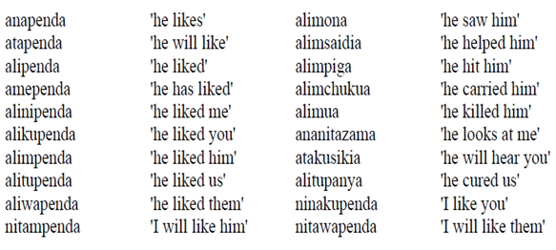

PRONOUNS | TENSES | VERBS
He: | Future: | See:
Him: | Present: | Help:
I: | Past: | Hit:
Me: | Past Participle: | Carry:
You: |  | Kill:
Us: |  | Look:
Them: |  | Hear:
 |  | Cure:
 |  | Like:

